NETWORKING

Workshop materials | Version 2  5 2019

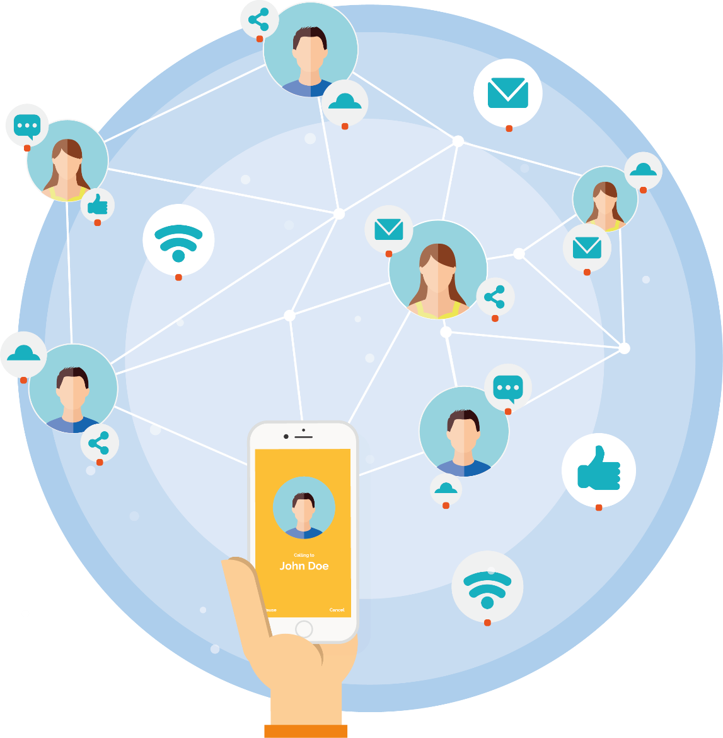
Content
Introduction 3
A. Basic introduction 4
1. Why networking? 4
2. Building of a business contact network 7
3. Taking care of contacts 9
B. More details 11
1. Crowdfunding 11
2. Platform selection 12
3. Financing methods 13
4. Taxes 14
Bibliography 16

Introduction
Business activities don't happen in a vacuum space. They are always based on the relationship between the person who has something to offer and the client. Intuition says that the more contacts the seller has, the easier it is for him to sell his product. This is not just about contacts with current customers, because they do not always need to buy that product. The idea is to "be around" when the customer wants to contact us. Entrepreneurs constantly monitor opportunities with their suppliers. The perfect situation is when the relationship is good enough that the supplier himself informs the entrepreneur about the opportunity. Caring for and developing such relationships is often the key to business development. In this case, as an example we may present the situation from the professional services market:
My college friend started working as a representative of a company working in the area of investment and insurance. This is a very difficult type of market, especially for young people, who often do not gain the trust as a life and financial adviser due to the inexperienced person's appearance. In addition, I perceived my friend that he is just out of step, unable to be convincing. I also thought he was too honest for the industry I had the idea of getting money from people by "pushing risky products."
Few years later, I met him and we talked about his work. I suggested him that it is quite hard piece of bread to walk around people and convince them to spend money on various investment products, especially if they are not much interested in it. He told me that this has not been the case for a long time. At this point, he was just coming to work only thinking of who to call with a proposal to buy the product. Due to his integrity, now he is often recommended. It is mainly influenced by the fact that on his own initiative he sends to clients some various instructions, even if the contract does not provide it. In this way, he maintains contact and takes care of them. Most of his conversations are with people who want to invest and insure themselves, and thus end up signing contracts. All thanks to honest gaining trust and new contacts from clients.
That simple story shows the power of networking. A large part of the hero’s efforts were absorbed in developing relationships and contacts that he made the basis for the development of his business. Networking is nothing more than 'establishing contacts and maintaining positive relationships in order to exchange information and mutual support in the professional sphere. Networking is the care of acquaintances, so that if necessary one can ask for help to a specific person who can and wants to help."

- Basic information
- Why networking?
The strength of networking is difficult to overestimate. When approaching the task of creation of contacts network, it is worth realizing that this will require a great deal of professionalism. If the creator is to be perceived and, above all, recommended as a business partner, then he must demonstrate values that are worth recommending and appreciating. Caring for the client, quality of contacts, cooperation is also taking care of one's own image, competence and professionalism. There is no point in building a business network if you have nothing to offer. On the other hand, many valuable initiatives may get stuck due to the lack of proper fuel, which is gaining an enthusiastic customer or recipient. Networking opens up many possibilities.

Picture 1. The positive aspects of networking

Source: Study based on Maciej Bielak’s book titled "Networking – dlaczego warto budować sieć kontaktów biznesowych?” (“Networking - why to build a network of business contacts”)

It is worth to look at the advantages of networking in terms of individual target groups. In business, customers' needs are first looked at and they are usually the main target of activities, often suppliers are equally important. Only then do business partners, public administration and other groups appear. In the case of creators of intangible culture, the situation seems to be more fluid and therefore more complicated. Frequently, viewers are not clients of the "strict sense" because they are not the ones who finance the projects. Financing can come from cultural support institutions or local government units, and the final recipient participates in the event free of charge. On the other hand, people not related to the project can use the crowdfunding platform to become sponsors of the event, which they will not directly use. Other creators who are seen as competitors as a result of participating in the same project may become collaborators. In turn, artists specializing in various fields can together create a group lobbying specific legal solutions in the sphere of culture. So for creators of networking culture, it seems to play an important role and create greater development opportunities than in traditional business.

Picture 2. Creator’s environment

Source: Own study based on materials from Exacto Sp. z o.o.

It is worth to pay attention to fact that noting that the above division due to the nature of the group is not the only one, because in each group there are people and institutions more and less important from the point of view of our business. Networking activities should be conducted in such a way that they are tailored to each of the groups. For example, information about upcoming projects, where our work will be presented, is best published via social media, but we will invite sponsors to this event in person. Information on the meeting bringing together creators will be sent via more formal channels. In turn, we will send information about a possible grant for culture and proposals for the implementation of a joint project to a selected group of recipients. This hierarchy is well traced through Christmas wishes. We will direct general wishes to your recipients who are followers of your Facebook profile. To institutions and recipients to whom we have contact details due to networking activities or previous cooperation, we will send emails or text messages - this group can be described as massive recipients. To people important from the point of view of our business, e.g. some sponsors, regular viewers, NGO representatives or administration, with whom we maintain good contacts, we will send a postcard by traditional mail - this group is tactical recipients. We can give a group of strategic people from the point of view of our operations, i.e. main sponsors, patrons, partners, or a per-sonally wishes.

Picture 3. Recipients’ groups

Source: Own study based on materials from Exacto Sp. z o.o.

Some commentators point out that there are many myths that may discourage using networking as unethical activities. That is why it is worth remind what that networking is not.

Picture 4. What a networking is not?

Source: The study based on a book by Maciej Bielak titled „Networking – dlaczego warto budować sieć kontaktów biznesowych?”

It should also be remembered that what is ethical and most desirable in relations with business partners or clients may be perceived differently by employees of public institutions.

Exercise (25 min.)
- What advantages of networking are most important to you? Speaking
- List people, companies, institutions and match them to individual groups from the drawing? Writing
- Which group consists of the biggest numer of contacts? Speaking
- In which group do you need the most to develop the numer of contacts? Writing
- Which contacts are strategic, tactical and which are massive for you? Speaking
- Building of a businecc contacts network
The story of the insurance agent presented in the introduction shows a series of actions that the hero took to create a network of informal contacts. There are initiating contacts, opening relationships with new people. It is maintaining contact through additional help, even if formal requirements do not specify it. There is also a command as a form of using of the current contact to acquire a new one. Analyzing networking activities, there are several main groups of activities in this area. Their compliance depends on whether the efforts made will be effective.

Picture 5. The principles of networking efficiency

Source: Based on, Katarzyna Błachacz, Dominika Przebięda, Ihor Skrypnyk, "Networking"

Creation of new relationships seems to be the most difficult challenge, especially for people who are reluctant to approach a stranger and start a conversation.
Particularly in such situations, efforts should be made to help yourself as much as possible. As with all professional activities, you must be prepared for each task. In the case of establishing direct contacts, you should prepare and practice several conversation topics in which we will feel good, which are interesting for the recipient and which present our creative work in an attractive way. It is worth remembering that brilliant and well-versed people in social contacts, most often consciously or do not use this pattern.
When starting networking activities, it is important to create the right atmosphere to conduct business talks. If we go to the company's president, we'll ask for 10 minutes at the secretary's office and this way, we will start a relationship, we put ourselves in a subordinate situation, we put pressure on the conversation so that it is interesting for the recipient and we operate in an environment in which our interlocutor feels definitely more at ease. Of course, sometimes this is the only way. However, it is better to give yourself a chance to have a better position to talk. It is much easier when the meeting is not held in the company only during the fair, when the president comes to us curious about the appearance of our stand, no one limits the time of conversation, and instead of breaking through the secretary a common friend presents us. Therefore, look for situations that group people with similar goals, such as trade fairs, conferences, conventions and industry meetings. In the case of creators, those may be themed events, fairs, performances or festivities. In this regard, it is also important to conduct conscious activities on the Internet: participation in groups and discussion forums, following events. A separate issue is also the use of crowdfunding platforms, associating the online community around the financing of various projects. A good method of acquiring contacts is participation in training, post-graduate studies or workshops, it is also worth returning to contacts from the university, high school or even earlier stages of education.
When planning how to contact you should also consider using a telephone, e-mail or even traditional mail. The idea is to make the contact method as optimal as possible. Sometimes a telephone conversation based on a mutual friend's recommendation can be much more effective than organizing a face-to-face meeting.

Picture 6. Contact methods used in networking
Source: Based on, Katarzyna Błachacz, Dominika Przebięda, Ihor Skrypnyk, "Networking"”

Exercise (25 min.)
- List events and other forms of networking activities, including online ones, in which you participate based on the drawing? Writing
- Also create a list of events, fairs and places on the Internet that can be helpful and which you have used so far? Writing
- Create a list of people and companies that can help you run and promote your creative activity, browse their websites or social profiles for what events they participate in? Writing
- Browse the ist taking into account the information who you may to contact and who is able to help you with ongoing activities. Create a conversation plan that will help you start and lead such a contact? Writing
- Taking care of contacts
It is worth remembering that the idea of networking is based on providing and getting help. The following example is a good example:
Every year a meeting of inhabitants takes place at one of Przemyśl housing estates. For an outside observer, it may seem that it is associated with considerable costs that residents must bear. There is a free grill for participants, there is a professional stage with sound system and a DJ, there are attractions for children. However, as it turns out, one of the residents who operates in this area deals with sound system and music, grill products are organized by another resident working in the butcher's shop, and the organization of the whole and obtaining funds for additional attractions are the responsibility of the local entrepreneur who is a councilor. Each of these people performs their tasks in a low-impact manner and this generates added value. In return, each of them receives an intangible asset in the form of appreciating commitment, can present their products or skills. In addition, the community integrates and is ready to take other joint initiatives.

Of course, despite the fact that the starting point in networking is readiness for free help, this does not mean that it consists in the free provision of services. The help here is mainly providing information - the recommendation of another creator, company, institution, providing information on an attractive offer. It is important to create an opportunity for the person or institution to be grateful for the help received. Maintaining contact is first of all remembering a person when the information we have may be useful to him. Based on the reciprocity rule, we can expect the same from our contact. Therefore, it should be remembered that if we recommend the services of someone from our network of contacts, that person should know about it.
When approaching networking professionally, creative tasks should include tasks related to informing the environment about what we do. You can use social media or websites for this. Well-composed communication tools will allow from the machine to reach the recipients with information. It should be remembered, however, that currently mailing or notifications from social networks may die in the flood of other information, especially paid commercial ads. Therefore, it is good to support such activities with traditional, telephone or direct contact. The so-called follow up, i.e. contact to find out whether the information has arrived and what impression it made, is a tool difficult to overestimate. This often requires additional work, but thanks to this our interlocutor will feel special. Depending on whether the recipient is qualified by us as an observer, mass, tactical or strategic, the intensity and the way of providing information will change.

Picture 7. Examples of degradation of networking activities relative to different groups of recipients

Source: Own study based on materials from Exacto Sp. z o.o.

Exercise (25 min.)
- Based on the task from the previous exercise consisting in matching contacts to groups due to their importance (strategic, tactical, mass, observers), plan information activities involving contact care:
- Create an action plan in social media, plan the frequency with which you will publish information. What will you inform about on social media? Writing
- What and who will you inform by phone or email? Speaking
- Write the plan of meetings/conversations with the most important people/institutions. Writing
- Think, who you are a strategic recipient for? How often and from whom do you receive information useful in conducting creative activity? Writing
- Use the available tools (e.g. Internet groups) to organize a notification system from places where you want to receive information? Plan the frequency with which you will check individual information pages, the frequency of contacts with institutions from which you expect information? Periodically verify the created plan. Writing

- More details
- Crowdfunding
The basis for networking is the human need to contact, communicate and share interests. These factors are also the main driving force of one of the greatest phenomena of our time - social media. At the same time, these media, on the principle of feedback, influence the way of communicating, making and maintaining relationships. One of the areas that social media has revolutionized is the sponsorship sector of various types of projects, including cultural initiatives. This is done using crowdfunding platforms. To simplify, crowdfunding is financing the project, often from scratch, based on collecting funds from various entities, most often connected in a network. And although the process itself is nothing new (many creators work on the principle of raising funds for the organization of the event from a large number of sponsors, or through pre-sales), online crowdfunding platforms have revolutionized this process. They give great opportunities to creators who want to obtain financing in a free market manner, while limiting the risk of losing their own contribution.
Crowdfouding is in fact a translation of the idea of networking into a project financing model measurable with the help of funds raised. It is still important to skillfully present ideas, mainly in social media, and to build a network of contacts. However, there is also an element of persuading some people from the network to provide tangible support to the presented project.
In the case of crowdfunding platforms, the entities supporting the initiative are usually individual users. Crowdfunding involves many issues related to the idea itself, the choice of the internet platform, how to reward donors, as well as fees and commissions.

Picture 8. Important issues of crowdfunding
Source: Based on the crowdfoundin4culture.eu platform.
- Platform selection
Currently, the quantitative and qualitative development of various types of crowdfunding platforms can be observed. Some of them operate at a general level, independent of the type of business or industry, some are dedicated only to creators of culture, while others focus on very narrow tasks, e.g. publishing music records.
In 2016-2018 IDEA Consult ran the crowdfunding4culture.eu website as part of a project for the European Commission. The map presented below from this no longer existing site allows you to quickly find out about the number of platforms supporting cultural projects in individual countries during this period.
Picture 9. Number of crowdfunding platforms supporting cultural initiatives in Central European countries.
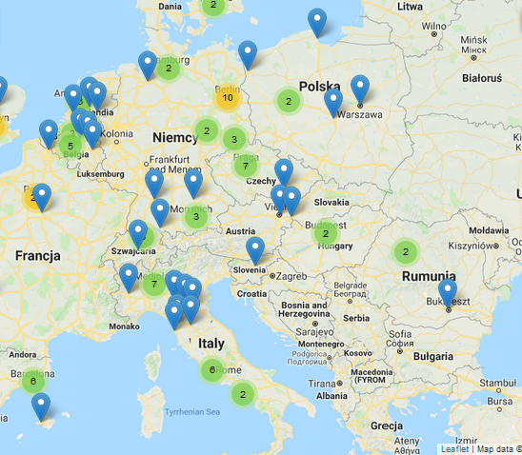
Source: Based on crowdfoundin4culture.eu
The main issues to consider when choosing a platform are primarily the specifics of the industry it is dedicated to. If it is a generic platform, it can be expected to involve a lot of people interested in supporting the idea. However, it should be borne in mind that they will be people focused on gaining benefits rather than selfless support, and our project will compete with a greater number of various initiatives. In the case of platforms dedicated to cultural projects, there is a greater chance that supporters will be guided not only by profit, but also by the support of ideas that go to them. However, these people can be definitely fewer. The issue of the territorial area of ​​operation looks similar - if the platform is focused on acquiring users from different countries, the number of users will be higher. However, the chance that they will be willing to support a local non-profit cultural idea will decrease. The easiest way to select this type of platform is to check the language in which it is available. If it is only a national language, it means that the platform counts on national coverage. It is also worth paying attention to the types of subsidies for projects available on the platform as well as such issues as fees and commissions.
- Financing methods
Crowdfunding is essentially about getting small amounts from a large number of donors. However, several financing models can be distinguished, the difference is essentially what the donor receives for project support.
Donation
This financing model looks like a charity collection, although it is not legally identical to it. People who support a given initiative do not receive any rewards.
Subsidy with a non-financial prize
This financing model goes a step further than subsidies and usually takes the form of pre-sales. People supporting a given project receive a tangible prize in the form of a product, event ticket, etc. The prize, however, does not take the financial form.
Peer to peer lending
The support takes the form of a loan of small amounts from many creditors, which is then repaid with interest on certain conditions.
Support in exchange for shares
Here, support takes the form of investment. The supporter does not expect a financial reward, but becomes a shareholder in a given business project. At this point, it is worth paying attention to the types of collections. There are two types of crowdfunding projects:

All or nothing
The entity creating the collection declares that a specified budget will be collected. If the target amount cannot be reached, the project cannot be completed. This is the case with projects that cannot be implemented in a reduced version.

You take what you collect
The entity creating the collection declares a specific target amount, but if it fails to collect it, it will be possible to carry out the project based on a smaller budget.
The last issue that appears with financing models is the issue of fees for using of the platform. They usually charge a commission for placing the project and a commission on the amount collected. This commission may depend on, for example, whether the project is of the "all or nothing" type, or "you take how much you collect". Some platforms may opt out of commission, while some may be completely free. It is a good idea to list and list all issues before choosing so that you can compare individual solutions. It is worth adding to the list of platform features information how much money and in what time was managed to collectively collect by a given platform, it will allow to assess the effectiveness of a given solution.

Exercise (35 min.)
- Create a list of crowdfunding platforms (you can also search the Internet for ready statements):
- List the types of projects a given platform supports (general, cultural, investment).
- Write down the commission charged on placing the project on the platform.
- Write down the commission on the collected amount. Writing

- Taxes
One of the most important issues to consider when planning activities on crowdfunding platforms is taxation. Due to legal complexity and different crowdfunding regulations, tax liability issues when choosing this form should be consulted with specialists, e.g. a legal or accounting advisor.
The nature of taxation may change, e.g. depending on the financing method chosen. For example, when choosing grant financing, if the supporter does not receive a prize, the amount of support is a donation. Different regulations will apply depending on the country. For example, in Poland you only need to pay attention that it does not exceed a certain amount and it should be remembered that the amounts of donations from the supporter add up from the last five years. In the case of a donation with a non-financial reward, the law already treats it as a presale, separate provisions will also govern the social loan, and separate issues of participation.
The moment when the tax liability arises is also important, it is necessary to consider whether the moment of donor's payment is decisive here, whether it is possible to collect a certain amount and start project implementation, or only when the amount is collected and the goal begins to be realized.

Bibliography
- Maciej Bielak „Networking – why is it worth to build business contacts network?”, https://www.corazlepszyportalbiznesowy.pl/art/networking-dlaczego-warto-budowac-siec, on 19.12.2018.
- Clarke Cole, “Social Media Best Practices for Nonprofit Organizations“, 2014.
- Katarzyna Błachacz, Dominika Przebięda, Ihor Skrypnyk, „Networking”, https://mfiles.pl/pl/index.php/Networking, on 19.12.2018.
- Amy Portfield, Phyllis Khare, Andrea Vahl, Facebook® Marketing All-in-One For Dummies, Hoboken 2013.
- Michelle Tullier, "Networking. How to find a job and achieve professional success thanks to networking ”, Wolters Kluwer Polska Publishing House - OFICYNA, Kraków 2008.
- http://www.crowdfunding4culture.eu/what-crowdfunding, on 21.12.2018.
- https://www.futuretech.legal/crowdfunding-a-prawo/ on 16.12.2018.

Katarzyna Błachacz, Dominika Przebięda, Ihor Skrypnyk, „Networking”, https://mfiles.pl/pl/index.php/Networking, on 19.12.2018
Maciej Bielak – “Networking – dlaczego warto budować sieć kontaktów biznesowych?” https://www.corazlepszyportalbiznesowy.pl/art/networking-dlaczego-warto-budowac-siec, on 19.12.2018
Maciej Bielak – “Networking – dlaczego warto budować sieć kontaktów biznesowych? https://www.corazlepszyportalbiznesowy.pl/art/networking-dlaczego-warto-budowac-siec, of 19.12.2018
See: Workshops material-Storytelling.
See: Workshops – Organization of events.
Katarzyna Błachacz, Dominbika Przebięda, Ihor Skrypnyk, "Networking", https://mfiles.pl/pl/index.php/Networking, for 12/12/2018, for L. Michelle Tullier, Networking. How to find a job and achieve professional success thanks to networking, Wolters Kluwer Polska Publishing House - OFICYNA, Kraków 2008.
http://www.crowdfunding4culture.eu/what-crowdfunding, on 21.12.2018
http://www.crowdfunding4culture.eu/what-crowdfunding, on 21.12.2018
Preparation of the chapter based on: http://www.crowdfunding4culture.eu/what-crowdfunding, on 21.12.2018

